**Name of Student: Ramit Bose**

**Reg.No.: 21BCE1316**

**Ex. No:8**

**Date :02-04-2023**

**Title:  Package, Component and Deployment Models**

**Aim:**

To Draw the UML Package, Component and Deployment Models for my application called “ATM MANAGEMENT SYSTEM”.

SOFTWARE USED: Star UML

**PACKAGE DIAGRAM**

Package diagrams are structural diagrams used to show the organization and arrangement of various model elements in the form of packages. A package is a grouping of related UML elements, such as diagrams, documents, classes, or even other packages.

The visual representation of the following has been mentioned:

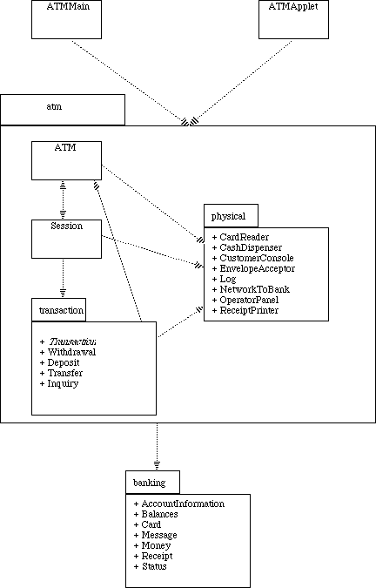

**COMPONENT DIAGRAM**

component diagrams show the structure of the software system, which describes the software components, their interfaces, and their dependencies. You can use component diagrams to model software systems at a high level or to show components at a lower, package level.

The visual representation of the following has been mentioned:

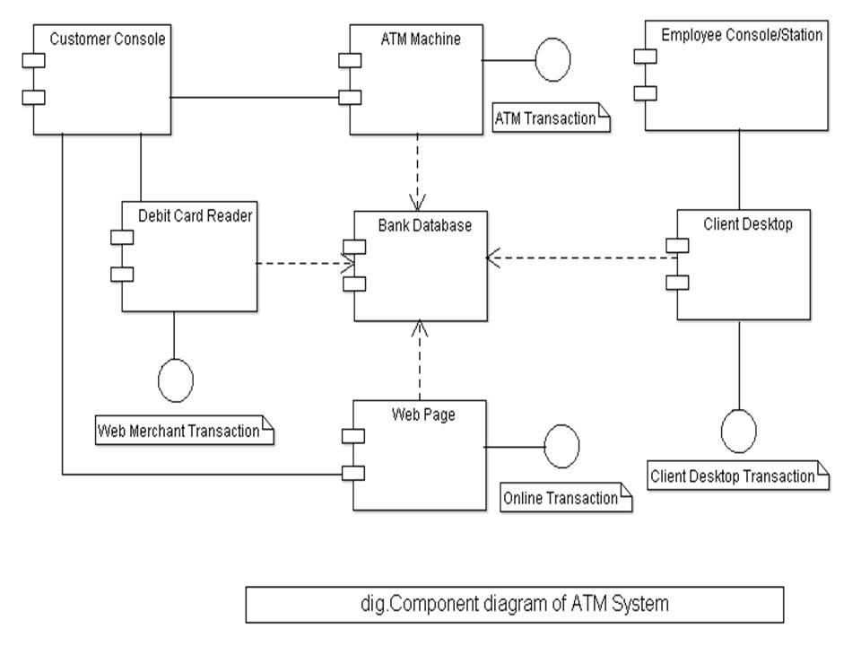

**DEPLOYMENT DIAGRAM**

deployment diagrams model the physical architecture of a system. Deployment diagrams show the relationships between the software and hardware components in the system and the physical distribution of the processing.

The visual representation of the following has been mentioned:

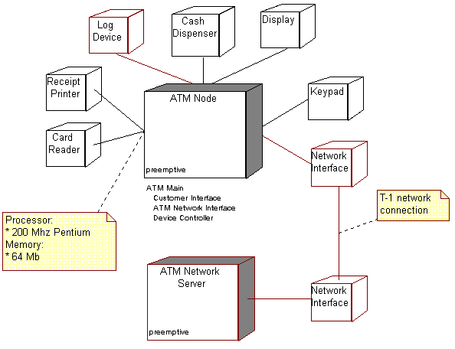

**RESULT**

Thus, the UML Package, Component and Deployment diagrams were made for the “ATM MANAGEMENT SYSTEM” APPLICATION and a visual representation of the same was analysed.